Project Planning Phase
Project Planning Template (Product Backlog, Sprint Planning, Stories, Story points)

Date | 08 October 2026
Team ID | SWTID-2026-1916
Project Name | Implement Client Script & UI Policy (Incident)
Maximum Marks | 5 Marks

Product Backlog, Sprint Schedule, and Estimation (4 Marks)
Use the below template to create product backlog and sprint schedule
Sprint | Functional Requirement (Epic) | User Story Number | User Story / Task | Story Points | Priority | Team Members
Sprint-1 | UI Policy Configuration | USN-1 | As an administrator, I can create the "High Impact Control" UI Policy on the Incident table with the condition Impact is 1 - High and Reverse if false enabled. | 2 | High
Sprint-1 |  | USN-2 | As an administrator, I can add a UI Policy Action that makes the Assignment group field mandatory when Impact is High. | 2 | High
Sprint-1 |  | USN-3 | As an administrator, I can add a UI Policy Action that makes the Urgency field read-only when Impact is High. | 1 | Medium
Sprint-2 | Client Script Development | USN-4 | As a user, when I set Impact to High, the Urgency field is automatically set to High (onChange Client Script). | 2 | High
Sprint-2 |  | USN-5 | As a user, I am prevented from saving a High impact Incident when Assigned To is empty and I see an error message (onSubmit Client Script). | 3 | High
Sprint-2 |  | USN-6 | As a user, I am blocked from changing the State field directly from the Incident list and I see an alert message (onCellEdit Client Script). | 2 | Medium
Sprint-3 | Testing & Validation | USN-7 | As a tester, I can verify mandatory enforcement: a High impact Incident with Assigned To empty is not saved. | 2 | High
Sprint-3 |  | USN-8 | As a tester, I can verify a successful save when Assigned To is filled, Urgency is auto-set and read-only. | 1 | High
Sprint-3 |  | USN-9 | As a tester, I can verify the reverse condition: changing Impact from High to Medium makes Assigned To optional and Urgency editable. | 2 | Medium
Sprint-3 |  | USN-10 | As a tester, I can verify that editing State from the Incident list is blocked and the value remains unchanged. | 1 | Medium
Sprint-3 |  | USN-11 | As a tester, I can verify that State can still be changed and saved from the Incident form. | 1 | Low
Sprint-3 | Documentation | USN-12 | As a team, we can document the configuration steps, test results and screenshots in the project report. | 1 | Low

Project Tracker, Velocity & Burndown Chart: (4 Marks)
Sprint | Total Story Points | Duration | Sprint Start Date | Sprint End Date (Planned) | Story Points Completed (as on Planned End Date) | Sprint Release Date (Actual)
Sprint-1 | 5 | 6 Days | 14 Sep 2026 | 19 Sep 2026 | 5 | 19 Sep 2026
Sprint-2 | 7 | 6 Days | 21 Sep 2026 | 26 Sep 2026 | 7 | 26 Sep 2026
Sprint-3 | 8 | 6 Days | 28 Sep 2026 | 03 Oct 2026 | 8 | 03 Oct 2026

Velocity:
Imagine we have a 10-day sprint duration, and the velocity of the team is 20 (points per sprint). Let’s calculate the team’s average velocity (AV) per iteration unit (story points per day)

Velocity calculation for this project:
Total story points = 5 + 7 + 8 = 20 | Number of sprints = 3 | Sprint duration = 6 days
Velocity = 20 / 3 = 6.67 story points per sprint
Average velocity per day (AV) = 6.67 / 6 = 1.11 story points per day

Burndown Chart:
A burn down chart is a graphical representation of work left to do versus time. It is often used in agile software development methodologies such as Scrum. However, burn down charts can be applied to any project containing measurable progress over time.
Burndown chart for this project (20 story points over 3 sprints):
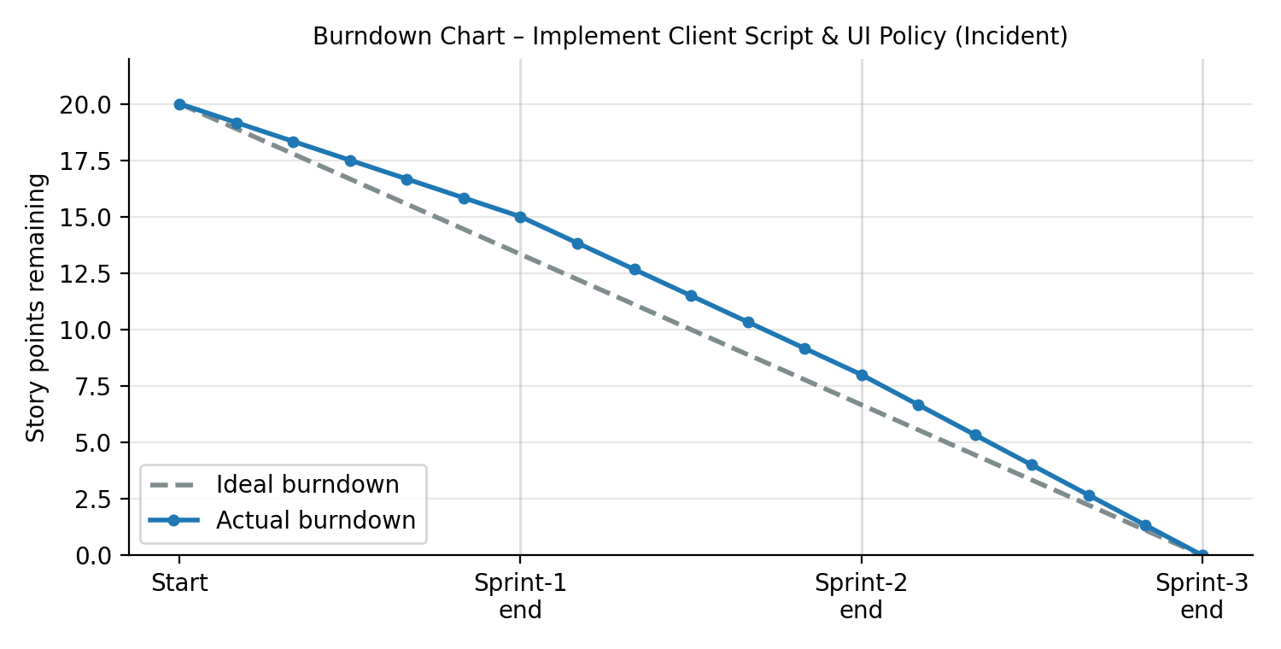

https://www.visual-paradigm.com/scrum/scrum-burndown-chart/
https://www.atlassian.com/agile/tutorials/burndown-charts

Reference:
https://www.atlassian.com/agile/project-management
https://www.atlassian.com/agile/tutorials/how-to-do-scrum-with-jira-software
https://www.atlassian.com/agile/tutorials/epics
https://www.atlassian.com/agile/tutorials/sprints
https://www.atlassian.com/agile/project-management/estimation
https://www.atlassian.com/agile/tutorials/burndown-charts

